**Document Release Note**

|  |  |
| --- | --- |
| **Document Release Number** | V 2.0.031022 |
| **Document Release Date** | 10th October 2022 |

Created By Teng Kong Leong Reviewed By Version Number A.0 Project Name

|  |  |
| --- | --- |
| **Created By** | Muhammad Faris Hakim |
| **Reviewed By** |  |
| **Version Number** | V 2.0.031022 |
| **Project Name** | AGROMON Configuration Tool |

**Document Revision History**

|  |  |  |  |  |
| --- | --- | --- | --- | --- |
| **Version No.** | **Revision Date** | **Revision Description** | **Review By** | **Pages/Section Affected** |
| V 2.0.031022 | 10th October 2022 | Initial document created | Muhammad Faris Hakim | All |
|  |  |  |  |  |
|  |  |  |  |  |
|  |  |  |  |  |

1. **OVERVIEW AND SETUP**
   1. **GENERAL GUIDE**

* MAIN PAGE

4

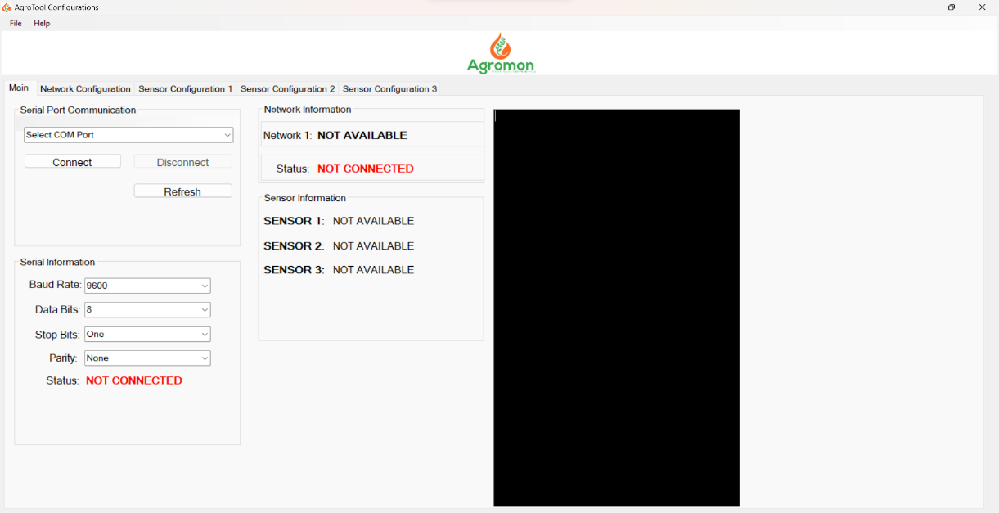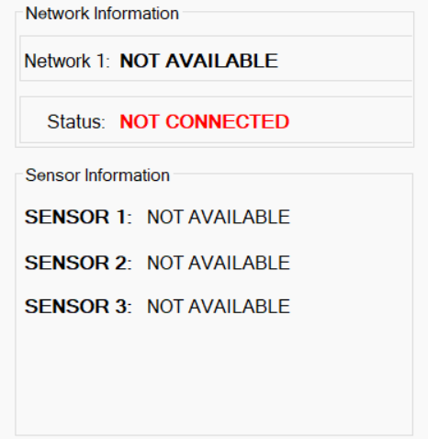

12

13

14

15

16

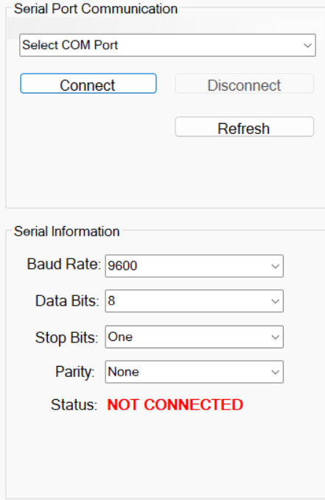

3

5

7

8

9

10

11

6

1

2

17

19

18

1. File
2. Help
3. COM Port
4. Connect Button
5. Disconnect Button
6. Refresh Button
7. Baud Rate
8. Data Bits
9. Stop Bits
10. Parity
11. COM Port Status
12. Network Name
13. Network Status
14. Sensor 1
15. Sensor 2
16. Sensor 3
17. Agromon Logo
18. Configuration Tab
19. Log Info

* NETWORK CONFIGURATION PAGE

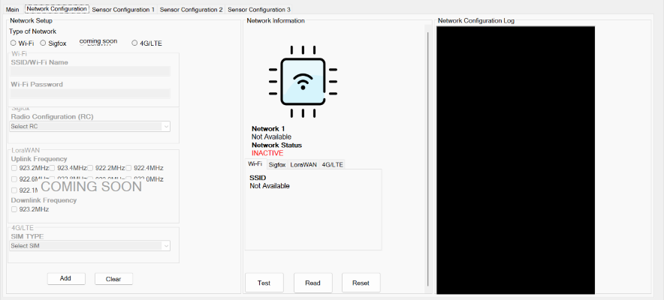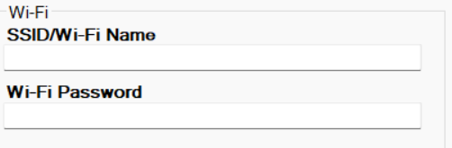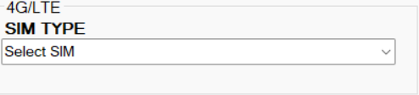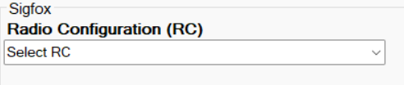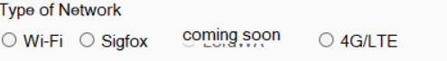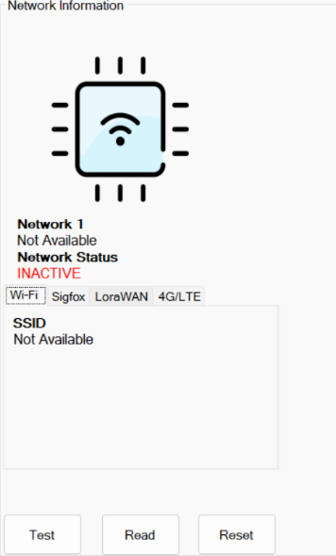

20

21

22

23

24

25

26

27

28

29

30

31

32

1. SSID
2. Password
3. Network selection
4. Sigfox RC selection
5. LTE selection
6. Add button
7. Clear button
8. Test button
9. Read button
10. Reset button
11. Network read name
12. Network set name
13. Network log

* SENSOR CONFIGURATION PAGE

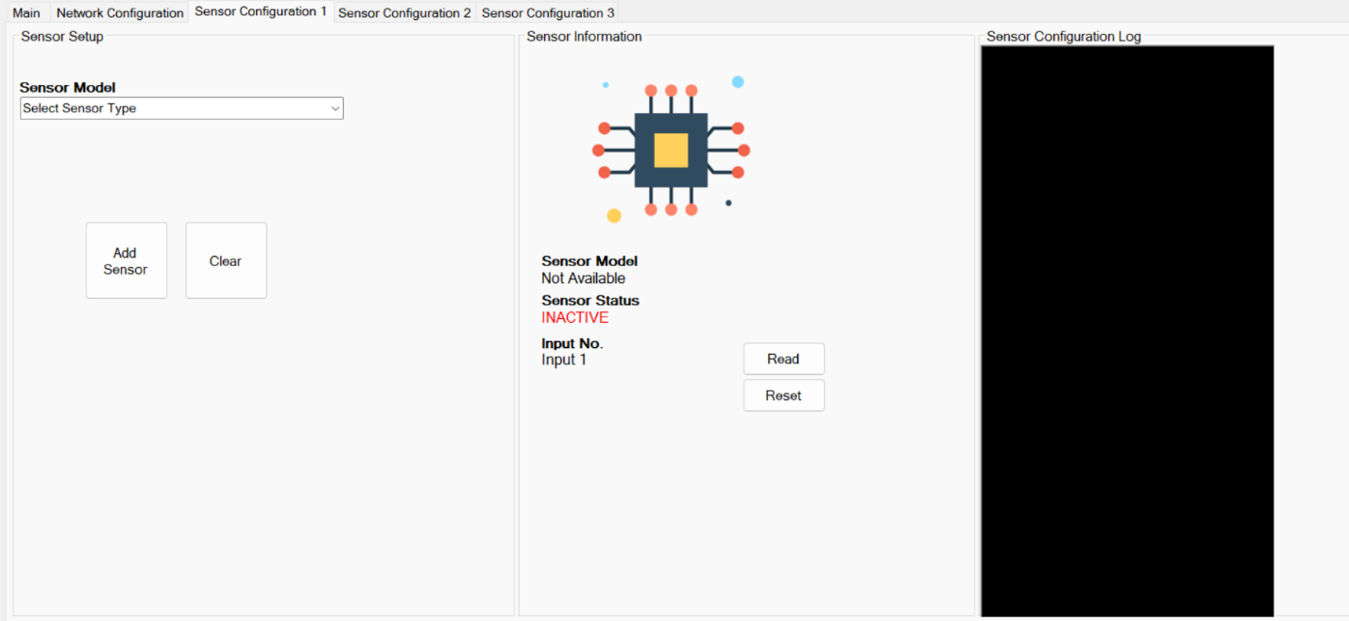

33

35

34

38

37

36

40

39

1. Sensor model selection box
2. Add sensor button
3. Clear button
4. Sensor model status
5. Input number
6. Read button
7. Reset button
8. Sensor log
   1. **PREPARING THE CONNECTION**

Connect the USB-B cable to RS485 Converter to AGROMON board to initialize he connection. Then connect the USB to computer. Press **6** to find available port. There will be text shown in **19** if COM Port is detected.

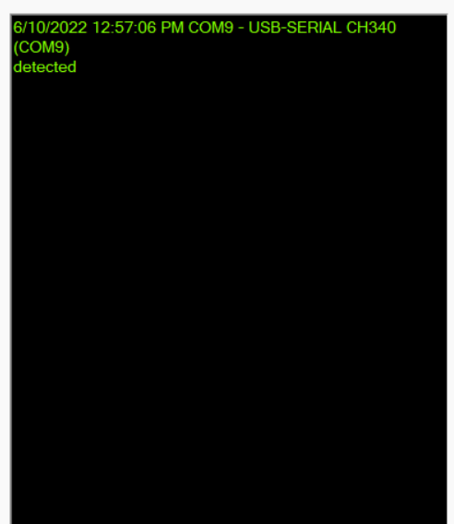

After the text shown the available port press the drop down menu

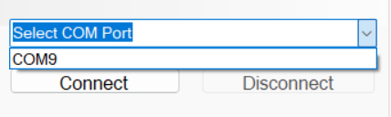

1. **UART CONFIGURATION**

Press on the REFRESH button to scan the available COM port. Pull down the COM port list and select the port number that is connected to Agromon. Upon selecting the correct COM port, press on CONNECT button to make connection. Figure 1 shows the user interface for the COM port settings.

The COM port settings for Agromon is as below:

Baud Rate: 9,600 bps

Start Bit: 1

Stop Bit: 1

Parity: None

Data: 8 bits

The communication setting is fixed to 9,600bps, 1-stop bit, 8-bit data, and No Parity. Other setting chosen will cause failure in communication.



